Algorithm for Parallel Implementation of FFTs
on SHARC Multiprocessor Systems
Rev 2 – March 7, 2007
Juan GAGO

Introduction
The advance of modern highly paralleled processors, such as the Analog Devices SHARC® family of processors, requires finding efficient ways to parallel implementations of many standard algorithms. This document explains how the fastest FFT implementation on SHARC multiprocessor systems works; a 256-point FFT is used as the specific example, but the mathematics and ideas apply equally to other sizes (no smaller than 16 points).
As we will see, the restructured algorithm breaks down the FFT into much smaller parts that can then be paralleled. In the case of the 256-point, the FFT is split into 16 FFTs of 16 points each and each. If we were to do a 512 point FFT, we would have to do 16 FFTs of 32 points each (and, also, 32 FFTs of 16 points each). These differences imply that it would be difficult to write the code that is FFT size-generic. Although the implemented algorithm is generic and applies equally well to all sizes, the code is not, and it must be hand-tuned to each point size to be able to take full advantage of its optimization.
Standard Radix-2 FFT Algorithm
Figure 1 shows a standard 16-point radix-2 FFT implementation, after the input has been bit-reversed. Traditionally, in this algorithm, stages in 1 and 2 are combined with the required bit reversing into a single optimized loop (since these two stages require no multiplies, only adds and subtracts). Each of the remaining stages is usually done by combining the butterflies that share the same twiddle factors together into groups (so the twiddles need only to be fetched once for each group).

Looking at the diagram of Figure 1, we would like to break the FFT into at least four parallel processes. We can do this by simply combining the data into blocks, four points at a time, i.e.:
1st block = {x(0), x(8), x(4), x(12)}
2nd block = {x(2), x(10), x(6), x(14)}
3rd block = {x(1), x(9), x(5), x(13)}
4th block = {x(3), x(11), x(7), x(15)}

These groups have no interdependencies and will parallel very nicely for the first two stages of the FFT. After that we are in trouble and the parallelism is gone. At this point, however, we could re-arrange the data into different blocks to ensure that the rest of the way the new blocks do not crosstalk to each other and, thus, can be paralleled. A careful examination shows that the required re-arrangement is an operation of interleaving (or de-interleaving), with new blocks given by:

1st block = {x(0), x(2), x(1), x(3)}
2nd block = {x(8), x(10), x(9), x(11)}
3rd block = {x(4), x(6), x(5), x(7)}
4th block = {x(12), x(14), x(13), x(15)}

Another way to look at these new blocks is as the 4x4 matrix transpose (where blocks define the matrix rows). Of course, there is a significant side effect—after the data re-arrangement the last stages will parallel, but will not produce data in the correct order. Maybe we can compensate for this by starting with an order other than the bitreverse we had started with, but let us leave this detail for the rigorous mathematical analysis that comes later.

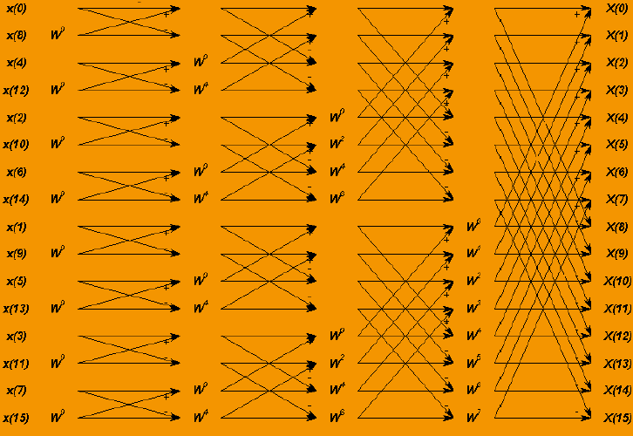
Figure 1 Standard 16-point radix-2 FFT

At this time, the analysis of the 16 point FFT seems to suggest that, in general, given an N point FFT, we would like to view it in two dimensions as a 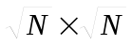 matrix of data and parallel-process the rows or columns, then transpose the matrix and parallel-process the rows or columns again. Another requirement that comes from this is that N must be a perfect square. As it turns out, we can dispose of this requirement, but that will be discussed later. At this time we are concerned with the 256-point FFT and, as luck would have it, 256 = 16².

Mathematics of the Algorithm
The following notation will be used:
N = Number of points in the original FFT (256 in our example),
M =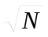 ,
will stand for the Discrete Fourier Transform (henceforth abbreviated as DFT) of x.
Now, given signal x,
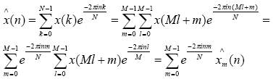
where:
x_{m} := x(Ml + m) (1)
and 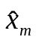 is this function’s M–point DFT. Now, we view the output index n as arranged in an M x M matrix (i.e., n = Ms + t, 0 ≤ s,t < M −1) Thus,
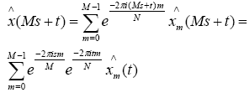
since , being an M-point DFT, is periodic with period = M. Thus,
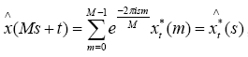 (2)
where:
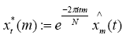 (3)
and 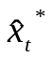is the function’s M–point DFT.

Implementation of the Algorithm
Equations (1), (2), and (3) show how to compute the DFT of x using the following steps (here we go back to our specific example of N=256, M=16):

1. Arrange the 256 points of the input data x(n) linearly, but think of it as a 16x16 matrix:
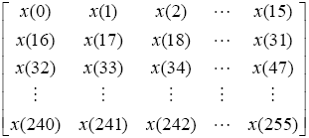

2. Using equation (1), re-write as:

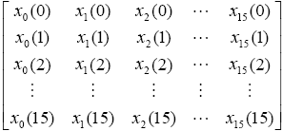

3. We now compute parallel FFTs on columns obtaining:

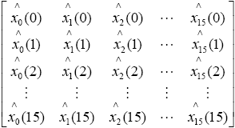

4. We point-wise multiply this by matrix exp (-2π tm / 256) 0≤ t,m ≤ 15 to obtain

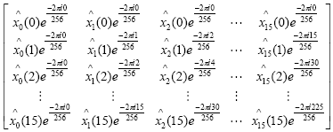

which, according to equation (3) is precisely
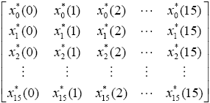

5. Now we would like to compute the 16-point FFTs of 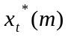, but these are arranged to be paralleled in rows instead of columns. Thus, we have to transpose to obtain

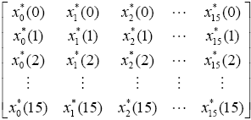

6. We compute parallel FFTs on the columns and use equation (2) to obtain

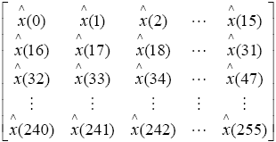

This is the FFT result that we want, and it is in the correct order! The math is done, and we are ready to consider the programming implementation. In the following discussion, we will refer to the steps outlined above as Steps 1 through 6.
Programming Implementation
We will go through the steps of the previous section, one step at a time.
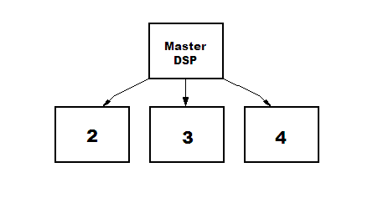
Figure 3 Link Ports interconnection in SHARC multiprocessor systems.
In this case there will be 1 master and 3 slaves but any number is possible.

- Steps 1 and 2. The input data is arranged in the proper order and distributed towards the slave DSPs by the master DSP.

- Step 3. The slave DSPs compute in parallel 16 FFTs of 16 complex points

- Step 4 and 5. The master DSP receives the data and arranges them in the proper order. While data is being arranged, the master DSP multiplies and transposes.

- Step 6. The slave DSPs compute in parallel 16 FFTs of 16 complex points.

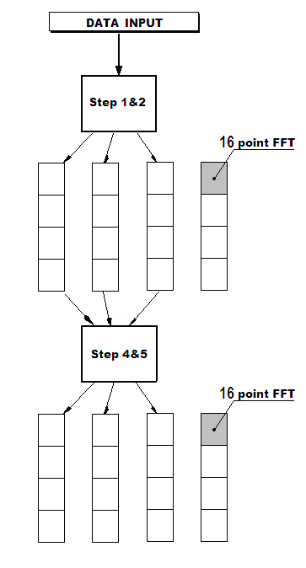
Figure 4 Flow Diagram of the algorithm mapping on four DSPs

This algorithm can be tested using the Matlab program in the Annex 1; that generates a cosine signal with a variable frequency.
Remarks
The example examined here is that of a 256-point FFT. At the time of writing this document, 64-point, 1024-point, 2048-point and 4096-point FFT examples using the algorithm described above have also been written in Matlab. In those cases, the FFTs were viewed as 8x8, 32x32, 32x64, and 64x64 matrices, respectively.

The 2048-point FFT was arranged in a matrix of 32 columns and 64 rows. 32 FFTs of 64 points each are done in parallel on the columns. Applying a point-wise multiply and transpose gives a matrix of 64 columns and 32 rows. Doing 64 FFTs of 32 points each in parallel on the columns completes the algorithm. The only side effect is that the parallel FFT portion of the code cannot be re-used (remember, the algorithm needs it twice) because the number of rows and columns is no longer the same. This results in longer source code, but the cycle count efficiency is just as good.

References

[1] Parallel Implementation of Fixed-Point FFTs on TigerSHARC® Processors. Analog Devices, Inc. http://www.analog.com/

[2] Inside of the FFT Black Box. Eleanor Chu, Alan George. CRC Press, 2000.

[3] The Fast Fourier Transform. E. Oran Brigham. Prentice Hall: New Jersey, 1974.
ANNEX 1: Matlab code
%%%%%%%%%%%%%%%%%%%%%%%%%%%%%%%%%%%%%%%%%%%%%%
%
% ParallelFFT.m
% Parallel Implementation of Float-Point FFTs
% DSP based FDOCT (Juan GAGO)
%
%%%%%%%%%%%%%%%%%%%%%%%%%%%%%%%%%%%%%%%%%%%%%%

clear all;
close all;
N = 256;
M = 16;
R = 16;

for f0 = 1:(N/2)

n = 0 : 1/N : 1-1/N;
x = cos(2*pi*f0*n);

X = fft(x);

%%%%%%%%%%%%%%%%%%%%%%%%%%%%%%%%%%%%

% Step 1&2: Arrange the input array in a R*M matrix
for row = 1 : R
A(row, 1:M) = x([1:M] + (row-1)*M);
end;

B = fft(A); % Step 3: 1st FFT stage: 32 FFTs of 64 complex points

% Step 4: Change the phase of the elements
for m = 1 : R
for k = 1 : M
C(m,k) = B(m,k) * exp (- 2 * pi * i * (m-1) * (k-1) / N);
end;
end;

D = fft (C'); % Step 5&6: 2nd FFT stage: 64 FFTs of 32 complex points
% Theses FFTs are optimizable thanks to real-signal properties

% % Arrange the output M*R matrix in an N-array
for row = 1 : M
Y([1:R] + (row-1)* R) = D(row, R:-1:1);
end;
Z = circshift(Y,[0 -R]);

%%%%%%%%%%%%%%%%%%%%%%%%%%%%%%%%%%%%

figure(1);clf;
title('Parallel FFT');
xlabel('freq samples');
ylabel('magnitude');
line(1:N, abs(X),'color','b','LineStyle','none', 'Marker','+');
line(1:N, abs(Z),'color','r','LineStyle','none', 'Marker','.');
drawnow;
end;

